# Meeting Summary: Tasks To Do and Design Changes

**Date:** 15/02/24

**Participants:**

* Member 1 (Dylan Carter - 720007761 - [dc713@exeter.ac.uk](mailto:dc713@exeter.ac.uk))
* Member 2 (Jamie Elder - 720011935 - [je497@exeter.ac.uk](mailto:je497@exeter.ac.uk))
* Member 3 (Victor Smith - 720087895 - [vphs201@exeter.ac.uk](mailto:vphs201@exeter.ac.uk))
* Member 4 (Daniel Hart - 700046191 - [dh590@exeter.ac.uk](mailto:dh590@exeter.ac.uk))
* Member 5 (Ziyad Alrubian - 710057514 - [zaa203@exeter.ac.uk](mailto:zaa203@exeter.ac.uk))

**Session Length:** 1 hour.

## Objective:

This meeting we would like to have tasks that everyone should be comfortable doing allocated to them and to finalise the design of the app with everyone understanding what they are going to contribute towards and how the application will shape up.

## Discussion Points:

### Base Application Design Change

We started off this session going through what we had done after the previous meeting and going through the design that Victor created and aligned it with what our base app should look like. We discussed how we thought the recipes should get their scores in accordance with the ingredients used and how planning a meal should be laid out. This prompted a design change with the databases as a new database for the ingredients would have to be introduced and the database for planning a meal would have to be altered and redone. After this change we were all in agreement with how the databases were presented and so we divided up the tasks.

### Task Allocation

We tasked Dylan with repurposing ‘Wordle’ into ‘Foodle’ as he is comfortable with coding games and HTML, also in the meeting Victor added a GitHub repository he found to the Kanban board which contained similar code to what was needed for our project. We asked Ziyad to create the code that allows a creation and a scanning of a QR code that would be printed off and used for our application, Victor was assigned with creating all the databases required for the app to function as he was most familiar with the design as he created it, Jamie was trusted to start the Django pages primarily the Login/Register pages, but to go further if he can in the time given of the next meeting.

### Quality of Life Design Discussion

Within this meeting we also had discussions about final quality of life changes for the app for instance about when joining a group should be done, about how the app should look, what to do for the ‘Foodle’ score, etc. The biggest take aways were that we shouldn’t focus on how the app looks yet as functionality for the first sprint is of highest priority, that you need to be in a group before you can choose to cook a recipe and that for this sprint we were going to have a tally which adds up the score you get on ‘Foodle’ each time you play it and you can play it as many times as you like.

### Expectations and Goals

It's also important to note that throughout the meeting we were discussing what the app should look like after the first sprint and the general idea was simplicity. We had to keep reminding ourselves that though there needs to be functionality we can add other complexities in the second sprint. This follows guidelines and ensures that we have an achievable goal before the deadline.

## Conclusion:

At the end of this meeting, we all understood where we were aiming towards in terms of our application and how we could start reaching the product we want to submit. With the tasks given we would have given ourselves all the foundation needed to complete our application with gamification and locations, while allowing each other to lean on our strengths and not be too overloaded with work.

## Next Steps:

1. Completing final pages of design.
2. Integrating code into the Django models.
3. Realistic expectations of our finished product for first sprint.

## Action Items:

1. Code our ‘Foodle’ game.
2. Code a QR creator and scanner.
3. Actualise database design.
4. Start on Log in and Register Pages.
5. Develop more pages if can in given time.

## 

# Meeting Related Images

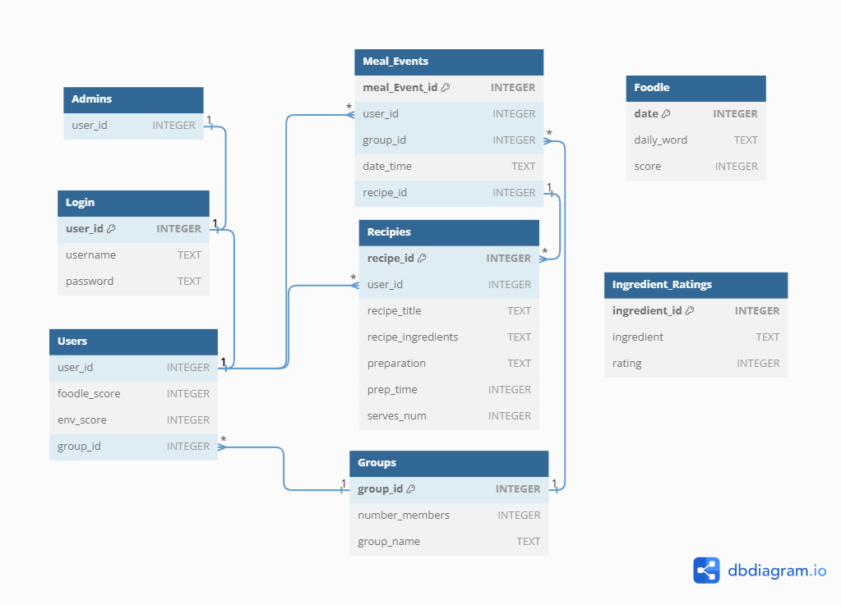

Above depicts the new design for the databases.